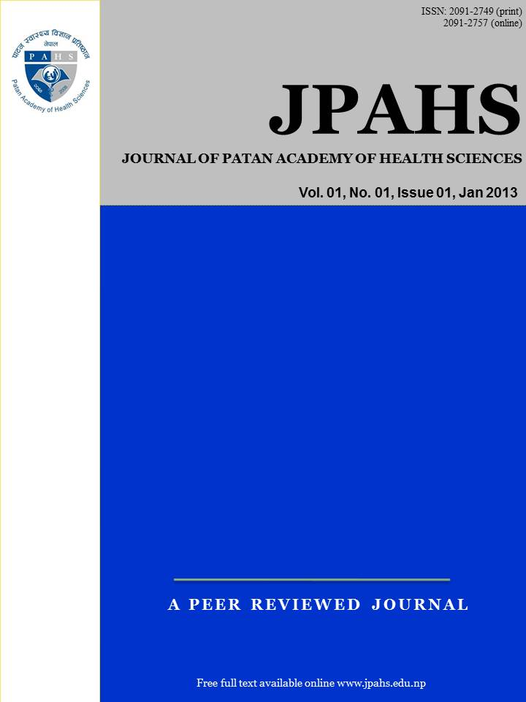
Coronavirus disease (COVID-19) outbreak, caused by the most recently discovered coronavirus, is currently affecting a large population across the globe. World health organization (WHO) has already declared COVID-19, a pandemic, and the world is fighting to contain the COVID-19 outbreak. Nepal has taken several preventive measures to control the coronavirus outbreak. However, some additional steps are needed to prevent community transmission of the disease. This brief communication discusses the government of Nepal actions and provides recommendations for the prevention and control of COVID-19 infection in Nepal.

Keyword: coronavirus, COVID-19, Nepal, pandemic, prevention
Correspondence
Dr. Kiran Sapkota
University of Iowa, Iowa City, Iowa, USA
Email: kiransapkota@gmail.com

Peer Reviewers
Asst. Prof. Dr. Ashis Shrestha
Patan Academy of Health Sciences

Asst. Prof. Dr. Sumana Bajracharya
Patan Academy of Health Sciences

Submitted
26 Apr 2020

Accepted
28 Apr 2020

How to cite this article
Kiran Sapkota, Ganesh Dangal, Madhu Koirala, Kalyan Sapkota, Ashmita Poudel, Shalik Ram Dhital. Strategies for prevention and control of COVID-19 in Nepal . Journal of Patan Academy of Health Sciences. 2020Apr;7(1):85-88.

DOI: https://doi.org/10.3126/jpahs.v7i1.28879

Abstract

Kiran Sapkota¹, Ganesh Dangal², Madhu Koirala³, Kalyan Sapkota⁴, Ashmita Poudel⁵, Shalik Ram Dhital⁶

¹University of Iowa, Iowa City, Iowa; ²Nepal Health Research Council/Kathmandu Model Hospital, Kathmandu, Nepal; ³National Open College, Kathmandu, Nepal; ⁴Bharatpur Hospital, Chitwan, Nepal; ⁵Nobel College, Kathmandu, Nepal; ⁶National Health Education, Information, and Communication Centre, Kathmandu, Nepal

Strategies for prevention and control of COVID-19 in Nepal
ISSN: 2091-2749 (Print)
2091-2757 (Online)

2091-2757 (Online)

We present our perspective to explore the actions, strategies and recommendations for the prevention and control of COVID-19 infection in Nepal, summarized in terms of problem identification and way forward.

Problem Identification- Nepal’s first case of coronavirus was reported on 13 January 2020, from a person traveling from Wuhan, China.^{1,2} The fear of increase in infection has led to psychological stress among some citizens.³ The Government of Nepal, the Ministry of Health and Population (MoHP), has accelerated preventive and diagnostic strategies, testing, hygiene education through mass media, 24-hour hotline services, social distancing, and contact tracing. The government has partnered with the local health sector, multi-sectorial, and international humanitarian assistance and formulated a high-level coordination mechanism to combat COVID-19 disease in the country.⁴ However, it has been reported that many provinces in Nepal lack logistic support to identify, diagnose and quarantine people quickly.

According to MoHP, regular screening is conducted among people who have come from foreign countries and have developed signs of COVID-19. Also, contact tracing has been going on for all the positive cases of coronavirus to cutoff further transmission. A team has been formed under the leadership of the secretary of the office of Prime Minister and Council of Ministers to monitor the condition of the disease and find out the measures in advance to minimize the outbreak of the virus. A high-level committee has also been formed under the prime minister to take precautionary measures against the possible outbreak of COVID-19.⁵ Our hospitals are not adequately prepared to deal with COVID-19 patients. The hospitals have a shortage of personal protective equipment (PPE), including gloves and masks, and infrastructure such as Intensive Care Unit (ICU). However, MoHP instructed all main and satellite hospitals to identify a dedicated area and beds with isolation facilities for COVID-19

Following the first case, there are altogether 42 coronavirus cases till 22 April 2020.⁶ Among the 42 confirmed cases, around 29 (69%) were related to travel by means of roadways or airways. Out of 29 cases, 17 cases were the Indian nationals who came to visit Nepal for various purposes. As the country cannot go for extended lockdown, more volunteers should be mobilized at the open border to bar entries to people suspected of coronavirus. Nepal needs to develop a robust system both at Tribhuvan International Airport (TIA) and many ports of entry at Indo-Nepal open border to register and for contact tracing even after lockdown is lifted. Mandatory quarantine is needed for suspected cases before they travel to other parts of the country.

Nepalese government public health funding comes from public expenditure (44%) and private sources (56%), and the country health system is underfunded.⁷ Half of the total health budget is made up of foreign aid, which indicates health budget dependency to others.⁸ The health budget is not sufficient to tackle the problems of infectious and chronic diseases. For example, the government budget for health programs increased from around 7% in 2010/11 to 9.6% in 2014/15.⁷ Again, the budget allocation declined to 4.4% in 2017/18. There has been no provision for emergency funds to tackle pandemic like COVID-19. Hence, the Federal government has established “The Coronavirus Prevention, Control, and Treatment Fund (CPCTF), which has received donations from various national/international organizations and individuals. Internal source of funds for the response of ongoing pandemic was from Nepal Oil Corporation, Nepal Telecom, offices under Ministry of Finance, Nepal Stock Exchange, different banks, corporative and individual donations.^{8,9} Moreover, the World Bank has also approved the COVID-19 Emergency Response and Health system Preparedness Project in Nepal to prevent, detect, and respond pandemic and strengthen public health preparedness.⁴ The training and orientation of health care workers on critical aspects of COVID-19 care and strengthening of dedicated hospitals in Kathmandu and provinces have geared up to manage COVID-19 with limited resources. More funds are still needed to train medical personnel who can handle COVID-19 patients, purchase of crucial medical equipment, access to soap and water, hand sanitizers, mass testing equipment, and construction of isolation centers. In addition to that Nepal needs to allocate funds for research on emerging diseases, a separate national unit such as Nepal Center for Disease Control and scale up laboratory services to improve its capability. Just as any pandemic, COVID-19 needs adequate emergency funds and leadership to develop comprehensive response capabilities. Besides, allocating funds for public, a public private relationship is indispensable as well as the healthcare system requires both a supportive public finance environment and timely action from government leaders.

Way forward- Several low-income countries in South East Asia, have been in lockdowns to control the spread of COVID. Nepal has also followed a countrywide lockdown (first imposed on 24 March; now extended till 7 May 2020) by which both travel and community transfer of COVID-19 cases were contained. The country had never experienced a pandemic like COVID-19 in recent decades and never had an infrastructure to control and mitigate disease at the community level. As the lockdown needs to be eased anyway, a model should be developed to reopen the country keeping in mind to create a robust system of phase wise opening, identifying asymptomatic cases, and managing identified cases, and so on to contain the spread of the disease. Learning from other countries, the government should develop diagnostic centers, isolation hospitals, and contract tracing mechanisms through a public-private partnership. Nepal’s diagnostic capabilities is limited and it has been slow to conduct screening by Polymerase Chain Reaction (PCR). As of April 25, 2020, only 9,666 PCR tests were done.¹⁰⁻¹² This suggests that the country should scale up testing and train human resources at the local, state, and federal levels. Also, the government needs immediate contact tracing resources throughout the country that can track the spread of the disease. Handwashing with soap must be established as a culture in sustainable way. Workstations such as offices, schools, colleges etc. set up should be established with a standard distance measurement. It is imperative for Nepal to explore ways of ensuring resources are made available to the frontlines using effective and timely execution of processes.

The COVID-19 pandemic is a warning call of the failing Nepal’s health care system to improve its capacity to deal with infectious diseases. Being a landlocked country, the only means of country sustenance is travel, and Nepal cannot close the Indian border for long, nor can it continue to close the international airport, which is a gateway for thousands of Nepalese to return home. The country needs adequate funding for health sectors, develop tools to trace contacts, strengthen public health sectors through volunteer mobilization, and better utilize mass media at the time of the pandemic. It is ideal to have local health facility that must have adequately trained health staff with PPE. A strong health promotion strategy of maintaining hand hygiene, pubic use of masks, maintain social distancing must be adopted to prevent COVID-19 pandemic.

Conflict of Interest
None

Funding
None

Author contribution
All authors contributed equally

Reference

- Bastola A, Sah R, Rodriguez-Morales AJ, Lal BK, Jha R, Ojha HC, et al. The first 2019 novel coronavirus case in Nepal. Lancet Infect Dis. 2020;20(3):279-80. DOI PubMed GoogleScholar Weblink
- Dhital SR. Important to wash your hands with soap and water to avoid corona (in Nepali). Health Today Nepal [internet]. 2020 Apr 19. [Accessed 2020 Apr 19). Weblink
- Karki B. Nepal takes steps to prepare for COVID-19: anxieties about the COVID-19 epidemic in Asia are high in Nepal. The Diplomat [internet]. 2020 Mar 9. Weblink
- The World Bank. Nepal: COVID-19 emergency response and health systems preparedness project. The World Bank [internet]. 2020 Apr 3; Loans & credits. Weblink
- Piryani RM, Piryani S, Shah JN. Nepal’s response to contain COVID-19 infection. Nepal Health Res Counc. 202018(46):128-34. DOI PubMed GoogleScholar PDF Weblink
- Shrestha M. On ending this lockdown. The Kathmandu Post [internet]. 2020 Apr 22; Columns. Weblink
- Dulal RK, Magar A, Karki SD, Khatiwada D, Hamal PK. Analysis of health sector budget of Nepal. JNMA J Nepal Med Assoc. 2014;52(194):811-21. DOI PubMed GoogleScholar PDF Weblink
- Uprety S, Lamichhane S. Health budgeting and financing in Nepal: policy perspectives. Discussion paper. Kathmandu: Health Research and Social Development Forum (HERD); 2016. 12p. PDF Weblink
- Khatri PP. Govt receives over Rs 1.59 bln in anti-COVID-19 fund. The Rising Nepal [internet]. 2020 Apr 3; Main news. Weblink
- New Spotlight Online. Nepal conducts nearly 50,000 COVID-19 tests, one person discharged from Bharatpur. New Spotlight News Magazine [internet]. 2020 Apr 25. Weblink
- Paudel S, Dangal G, Chalise A, Bhandari TR, Dangal O. The coronavirus pandemic: what does the evidence show? J Nepal Health Res Counc. 2020;18(46). DOI PubMed GoogleScholar PDF Weblink
- Hamal PK, Dangal G, Gyanwali P, Jha AK. Let us fight together against COVID-19 pandemic. J Nepal Health Res Counc. 2020;18(46). DOI PubMed GoogleScholar PDF Weblink

